Print Your Name on the Line Next to NAME.
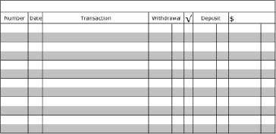
1500.00
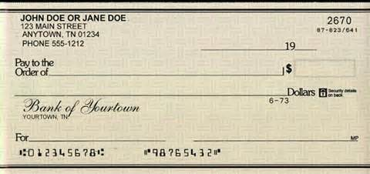
2672
2670
2671
Name:__________________

Name:__________________
Name:__________________

Bills to Pay: 4-1-14 Vectren: $100.00 Paycheck: 4-3-14 Jobs R Us: $375.00
4-2-14 Mr. E’s Apartments $475.00
4-4-14 Schnuck’s $215.00

