Industrialization Document Packet

Document #1: Excerpt from a letter by Lowell Mill girl, Mary Paul, to her father
(World History: Patterns of Interaction, 2009, p. 741)

Background: Mary Paul worked in a textile factory in Lowell, Massachusetts. In an 1846 letter to her father in New Hampshire, the 16-year-old expressed her satisfaction with her situation at Lowell.

I am at work in a spinning room tending four sides of warp which is one girl’s work. The overseer tells me that he never had a girl get along better than I do … I have a very good boarding place, have enough to eat … The girls are all kind and obliging … I think that the factory is the best place for me and if any girl wants employment, I advise them to come to Lowell.

1a. What kind of work is Mary Paul engaged in?

1b. Does Mary Paul like or dislike her job? GIVE SPECIFIC EVIDENCE from the excerpt to support your choice.

1c. What is a reason that supports your choice in 1b that she did not specifically mention?

1.d Is this document better evidence for the POSITIVE or NEGATIVE effects of industrialization? WHY?
Document #2: Early Industrial Plant
(source: http://www.encarta.msn.com/find/MediaMax.asp?pg=3&ti=1741500823&idx=461530293 )
Background: As the Industrial Revolution spread to the United States, plants such as this textile factory appeared. Soon the production of exports outpaced import of goods, and by the late 1800s America emerged as the world’s largest industrial power. This success did not come without a price, however, industrial growth brought with it a host of environmental pollution problems.

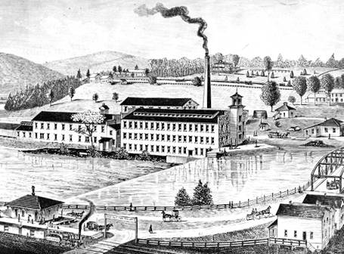

3a. What positive impacts would this factory bring?

3b. What negative impacts would this factory bring?

3c. Is this document better evidence for the POSITIVE or NEGATIVE effects of industrialization? WHY?
Document #6: Picture of an Urban Tenement.
Source: Encarta Online Encyclopedia
http://www.encarta.msn.com/find/MediaMax.asp?pg=3&ti=1741500823&idx=461573903

Background: As countries industrialized, they also urbanized. This was a result of people moving to cities in large numbers in order to gain factory jobs.

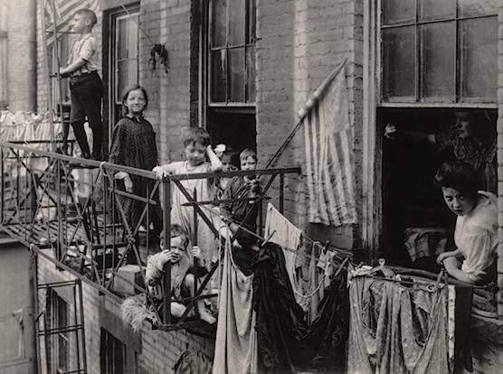

6a. What were living conditions like for many urban dwellers?

6b. What positive details do you see in the picture? What negative details do you see?

6c. Is this document better evidence for the POSITIVE or NEGATIVE effects of industrialization? WHY?

