Name: _________________________________ Date: __________________________
Cain World History Period:_________________________

Ancient Greece
DBQ

Directions: Answer the questions using evidence from the documents provided.

Tips about answering Document Based Questions

- Be sure to use complete sentences
- Restate the question when answering (complete answers are complete thoughts!)
- Consider the source (ask yourself who supplied the information and when)
- Examine the supplemental information as well as the document when planning your response

Document 1

In the ancient Greek city-state of Athens, citizenship carried both rights and responsibilities. A male citizen was expected to help defend Athens in war, to serve on a jury, and to participate in debates about issues. Pericles, a great leader in Athens, said:

“We do not say that a man who takes no interest
in politics is a man who minds his own business;
we say that he has no business here at all.”

- What did Pericles think about citizens who did not participate in politics?

- What words lead you to think this?

Document 2
The expression below was supposed to be the parting cry of mothers to their sons. Mothers whose sons died in battle openly rejoiced.

"Come back with your shield - or on it.”

- How does this attitude reflect Spartans values?

Document 3

Socrates was known for his teachings in Athens. The following is one of his most famous quotes:

“I am not an Athenian or a Greek, but a citizen of the world."

Socrates, from Plutarch, Of Banishment
Greek philosopher in Athens (469 BC - 399 BC)

- What is Socrates trying to state with this quote?

Document 4
Sparta and Athens were the dominant city-states in ancient Greece.
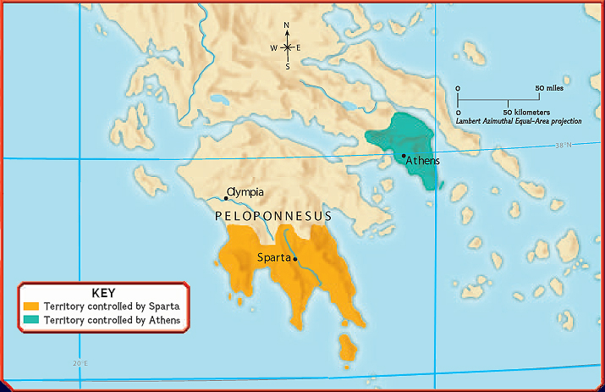

- How many miles apart were Sparta and Athens?

- Which city-state’s geography might make it more open to attack in a military battle and why?

Document 5

The small number of citizens made a direct democracy possible in Athens.

Comparing Governments
 | Athenian Democracy | American Democracy
Type of Democracy | Direct | Representative
Right to Vote | Only adult males born in Athens | All citizens, male and female age 18 or over
Laws | Proposed by the council and approved by a majority in the assembly | Approved by both houses of Congress and signed by the president
Citizen Involvement | Citizens with voting rights can vote for or against any law | Citizens with voting rights can vote for or against the officials who make the laws

- In Athens, how was a law approved?

- Which government granted the right to vote to more of its population? Explain.

